**Results for final paper:** *Dolomedes minor* male courtship depending on female mating status

|  |
| --- |
| 1. **Global Investigation** |

**• Male total courtship duration ~ Female mating status**

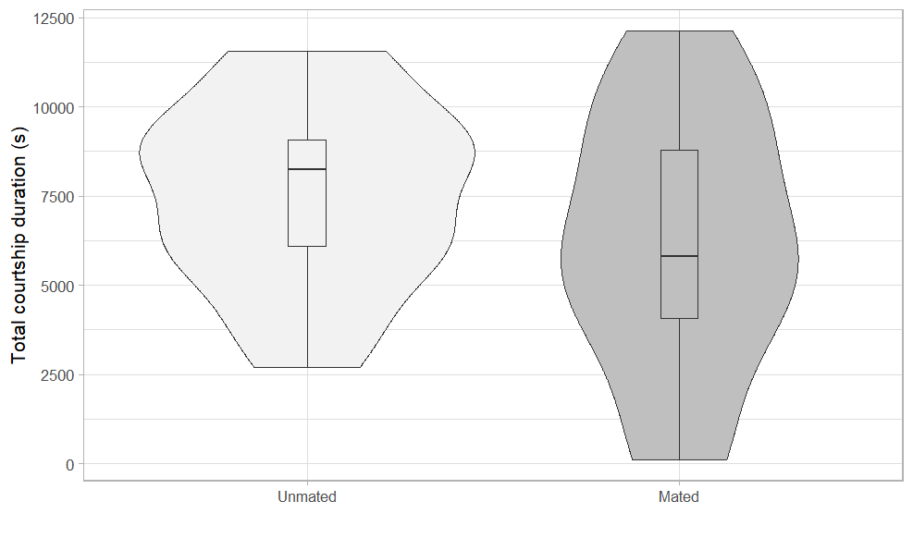

Wilcoxon signed-rank test for paired values: V = 86, P = 0.1514 (Not significant)

*Notes:* I’m considering not including the number of courtship attempt and the mean duration of those attempts. The number of courtship attempts is really dependant on the female aggressiveness: when a female attack, the male flees and start another courtship, which I reckon might not bring any information on the adaptation of male courtship. Though, there’s room for discussion as female aggressiveness might be dependent on her mating status, so is a response of male courtship to female aggressiveness interesting here? About the mean duration of each attempt, I think it might bring some redundancy in the information.

*Question to ask*: Is it a proper way to represent paired data with violin plots? Could someone check my script to see if I haven’t made any mistakes (ask Cedric Wolf for improvement)? Should I start cleaning my scripts as much as I can for the appendix?

**• Latency to mount the female ~ Female mating status**

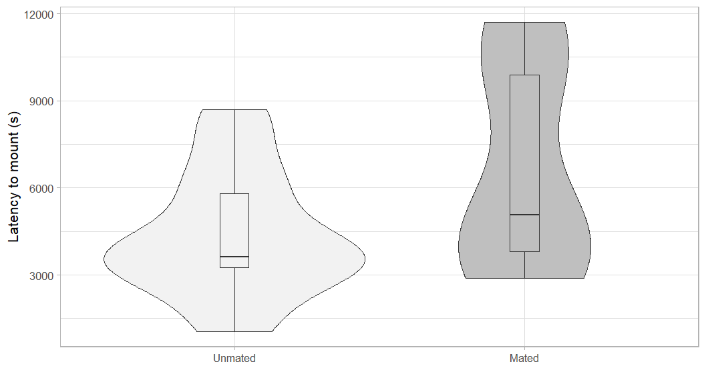

Wilcoxon signed-rank test for paired values: V = 3, P = 0.009 (significant)

*Notes:* This result is significative with males mating with already mated females having a longer latency to mount. The ‘problem’ with this result, is that it should be the other way: males with mated females should have a quicker mount to lose less energy, which was already investigated this way in *Rabidosa punctulata* (Lycosidae). I reckon an explanation for this result might be the mated females being more aggressive and less receptive, which brings back the question of the female aggressiveness.

**• Number of attacks of the female ~ Female mating status**

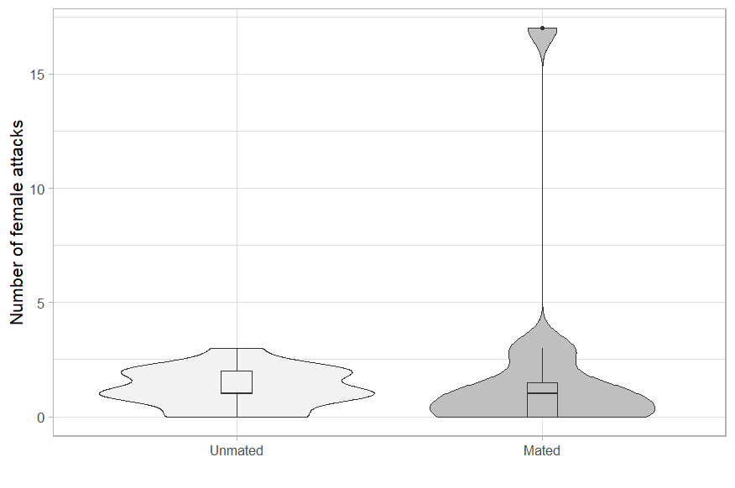

Wilcoxon signed-rank test for paired values: V = 49.5, P = 0.42 (Not significant)

*Notes*: Based on the question of what to do with female aggressiveness, I tried to analyse it and it didn’t bring anything interesting (even when removing the outlier). Thus, I really think that there is no point in adding this kind of things about female aggressiveness

I also tried other ‘latency stuff’ such as the latency to attack (not significant), but which is sill within the question about female aggressiveness; the latency to touch (not significant), but which might bring some redundancy with the latency to mount; the latency to copulate (not significant), which feels a bit weird to use as the first group is constrained to always have a successful copulation (So, I don’t know if that’s a problem here).

• **Total mount duration ~ Female mating status**

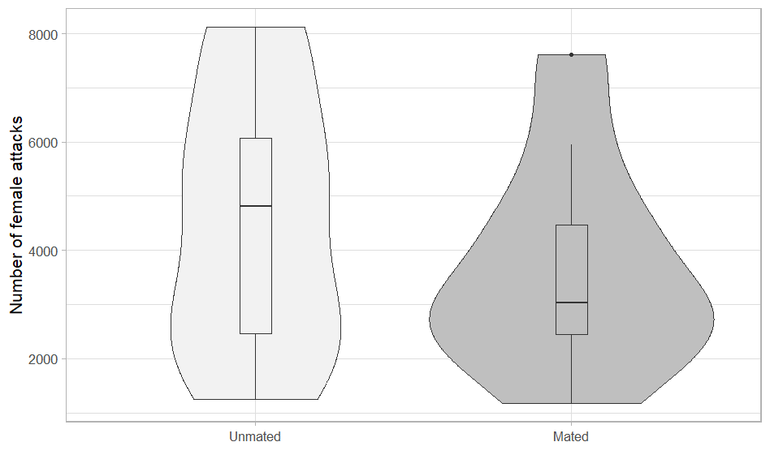

Wilcoxon signed-rank test for paired values: V = 38, P = 0.3223

*Notes;* I think including these results might be interesting as it brings more consistency in the study: first having the total courtship duration, the total mount duration and the latency to mount. It cuts the courtship into the two phases that are described later in the networks: approach and mounting. A question might be to know how far I want to standardize this and what I mean is that maybe I could only compare the time of the first approach + first mounting, the same way it is done for the networks.

I haven’t included the number of mounting attempts and the mean number of those attempts for the same reasons as seen before for the total courtship duration.

|  |
| --- |
| 1. **Behaviour description of *Dolomedes minor* male behaviour** |

[See the ethogram in my report]

*Notes:* I think adding more description of the reproduction could be an interesting thing (such as the way males are only using leg rubbing when they’re mounting the female, etc). It could also be possible to add a drawing of the male position when mounting the female and trying to reach the genitalia. Overall, I think I could give more room in my final paper to the description of courtship behaviour, as it was done on the paper on funnel-web spiders.

|  |
| --- |
| 1. **Vibration frequency analysis** |

*Notes:* This is currently not in my report but I would definitely love to add it in my report. The idea would be to measure the frequency of the vibration behaviour performed by the males and compare it between the two groups. I would need to find a proper way to do it: maybe for each behaviour, measure for each male the frequency of the 10 first time he’s doing this behaviour, make a mean, and compare the distribution of those means between the two groups (avoid pseudo-replication). I’m also wondering for this if I should compare the frequency as the number of ‘tap/wave’ per second or per behaviour.

Those results would definitely fit pretty well within the energic investment question.

|  |
| --- |
| 1. **Courtship structure networks** |

[See my report]

*Notes:* What is currently in my report is pretty nice, I think. My main questions would be to know if I should add more behavioural sequencing: as there is only 10 individuals in the second group, but as we’ve already discussed with Chrissie, it is still consistent; to know if I should add the female behaviour; and to know if it is a problem or not to not have the outcomes of the courtship (meaning copulation, sexual cannibalism or final retreat of the male, but I reckon it could be justified as a decision to standardize things by only doing the first male attempt).

Another simple question would also be: colour or not?

About the statistical comparison between the two networks. I’m currently doing tons of Wilcoxon tests between everything which I need to clean and make sure that they’re all properly done (they were done quickly as I needed them for my report) but also, I’m wondering if there might not be another way to analyse this?

|  |
| --- |
| 1. **A story of messy models** |

[See my report for my models]

Currently I do have models on impact of female aggressiveness on courtship parameters, which brings back the question of female aggressiveness + as I’m changing my global courtship parameters, I’ll need to change them too if I’m keeping them.

I also have models for the impact of courtship global parameters on the mating outcomes, but they haven’t brought anything interesting + I don’t feel like they’re really consistent within my scientific question.

Overall, I’m just trying to consider if I should keep those models or not (especially as I’ll bring analyses on the vibrations which are more valuable). Maybe at least, the models on the impact of female aggressiveness might be solution for this recurring question (However, I’m only taking into account the clear attacks of the female and no other signals). And finally, they should be improved by adding the fact that two males were the same between the groups and one male was used two times in the second group.